CCT College Dublin

Assessment Cover Page
To be provided separately as a word doc for students to include with every submission

Module Title:
 | Machine Learning
Assessment Title: | CA2
Lecturer Name: | Marina Lantorno
Student Full Name:
 | AFIA SERWAA
Student Number: | SBA23069
Assessment Due Date: | 30/06/2024
Date of Submission: | 30/06/2024

Declaration

By submitting this assessment, I confirm that I have read the CCT policy on Academic Misconduct and understand the implications of submitting work that is not my own or does not appropriately reference material taken from a third party or other source. I declare it to be my own work and that all material from third parties has been appropriately referenced. I further confirm that this work has not previously been submitted for assessment by myself or someone else in CCT College Dublin or any other higher education institution.

Program title:

Diploma in Data Analytics for Business

Machine Learning I&II

Lecturer: [Marina Lantorno ]

Student: [ Afia Serwaa]

[ 30/06/204]

Table of Contents

1. Introduction 5
2. Exploration 5
3. Conclusions and recommendations 5

Table of Figures

Figure 1 – Description of Figure 6

- Introduction

The purpose of this report is to explore how an IT company give cloud-based solutions to business. The aim of this assessment is to predict the demand of a software product increase over time. The data of a software data will be cleaned and identify any trends. The time series forecast of the company’s software will be evaluated. A model to build a classification to identify how urgent, high, medium and the low system will be reviewed. Anomaly detection of the system logs to check the security threats and failures will be discussed. Lastly, a recommendation system to identify 3 recommendations of a random customers will be reviewed.

- Exploration

First, the needed libraries were imported to be able to conduct the analysis. The data frame was called “dataset”. The Dataset.info is used to check the datatype. The Dataset.isnull().sum() is used to check missing values in the dataset. There was no missing values in the dataset. The date was converted in to index. The summary statistics of the dataset was described to identify the mean and the standard deviation. The code can be found in Jupyter notebook. Some visualisations was created to be able to identify the trends in the columns of the dataset.

The software-9 products was visualised to see how is been distributed. The highest value is 120 to 130. Second highest is 110 which shows the trends or how many products is being purchased.

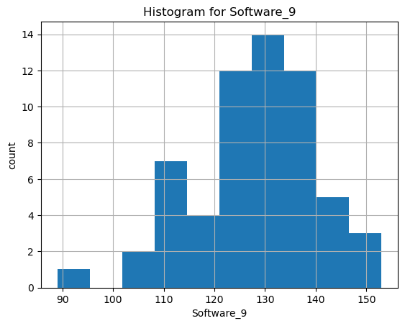

Another software product was visualised to see the distributed trends. In the below graph the highest software value in the software_12 is 110. The second highest is 120. Followed by 100 and 130. The graph shows how the software-12 is evenly distributed.
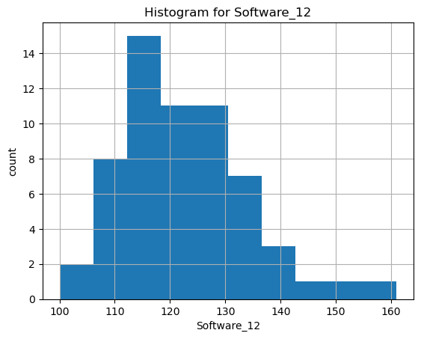

The distribution of software_5 is distributed to identify the highest trend. The value of 45 has the highest trend . Followed by 50. This shows the demand the software 5 . for the company to focus on what need to be improved in the low values.
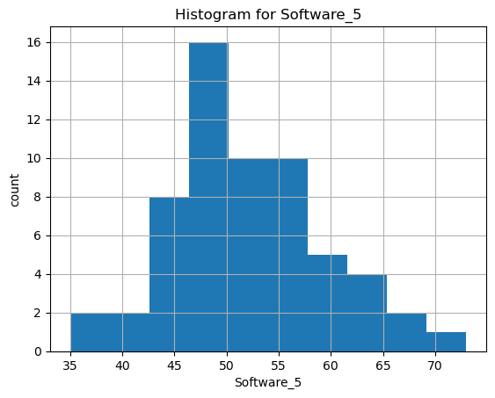

Furthermore, 4 different software products was visualised using a line plot, to know how each of the products are performing. Software 1, Software 2, Software 3, Software 4 are plotted in line plot. The x-axis represent the date time of the software and Y-axis for the software. The software_1 has an increase in line in the year 2018. And Software 3 has an increase up and down in the year 2018. And 2019 there was a decrease in sales. From 2019 to 2022 software 3 has a stapple sales. Software 4 has been changeable with the sales, as the line keep moving up and down sales. The graph shows how the software products is seasonal.

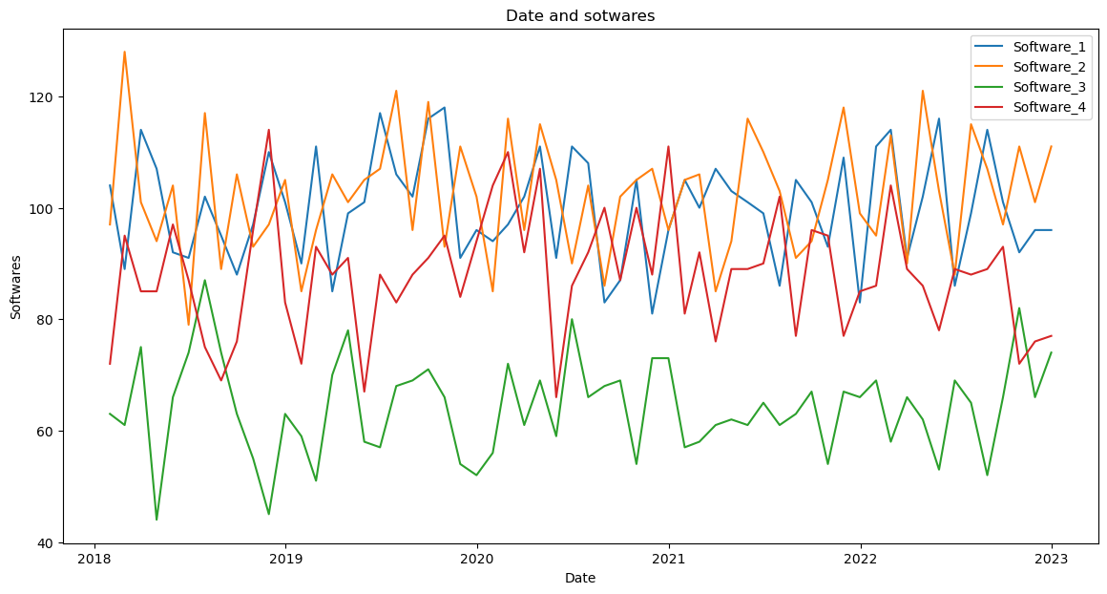

Q2. Develop a time series model to forecast monthly demand for the company's top software products for the next year. Evaluate the model based on its accuracy and ability to handle seasonal variations.
The object categories was encoded to categories. The object was encoded to numerical columns.
The object column was created and encoded to numerical. The ‘object’ columns was renamed as catcol. The code can be found in Jupiter notebook. Dataset head() was used to display the columns and rows.
Another column was created named as Total. The code sums a new column name “Total”. The code can be found in Jupiter notebook. The Total column will be the variable I will be working with.
A new data frame name was created called df_total. A ducky fuller test is used to check the
Stationarity or seasonality of the data. The code can be found in Jupiter notebook. The result of the ADF statistic is -6.312716405221322, which indicate that the series is non-stationary which is
Moving. Meaning I reject the hypothesis. The results of the p-value was 3.205309121239001e-08,which indicate that the p-value is stationary because is less than alpha. Based on these results the data is split into training and testing set to be able to build the time series forecasting model. The code can be found in Jupyter notebook.

The model Arima model was defined. The variable Total will be used for forecasting. The Arima model was use in the forecasting. Prediction for 30days was made as the code can be found in Jupyter notebook. The mean Absolute Percentage Error was calculated, this is calculated using the actual and forecasting values of Total column from the dataset. The result of the Mape value is 1.8950469541895099 indicating there is 1.89% of error. These results mean there will be high forecasting accuracy forecasting. The results was visualised . The code can be found in Jupyter notebook.
The visualisation below is forecast for Arima software for 30 days. The orange colour is the forecast Test set that display how the model predictions matches the actual values during the test set. The green line is the forecast 30days of prediction for the model.
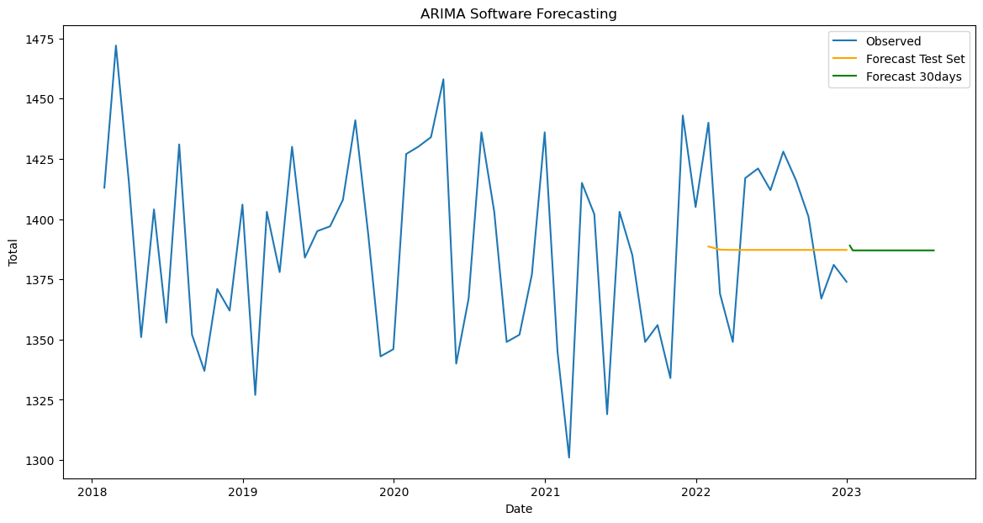

Forecast-df-30 is use to print the forecast for 30days

2023-01-08 1389.0
2023-01-15 1387.0
2023-01-22 1387.0
2023-01-29 1387.0
2023-02-05 1387.0
2023-02-12 1387.0
2023-02-19 1387.0
2023-02-26 1387.0
2023-03-05 1387.0
2023-03-12 1387.0
2023-03-19 1387.0
2023-03-26 1387.0
2023-04-02 1387.0
2023-04-09 1387.0
2023-04-16 1387.0
2023-04-23 1387.0
2023-04-30 1387.0
2023-05-07 1387.0
2023-05-14 1387.0
2023-05-21 1387.0
2023-05-28 1387.0
2023-06-04 1387.0
2023-06-11 1387.0
2023-06-18 1387.0
2023-06-25 1387.0
2023-07-02 1387.0
2023-07-09 1387.0
2023-07-16 1387.0
2023-07-23 1387.0
2023-07-30 1387.days

The Sarimax model was defined to be able to compare the two models. The “Total” variable will used for forecasting 30days. The next part is forecasting for the test size. The forecast steps test will help to compare the forecasted values with the actual values in the dataset. A prediction for 30days is made as the code can be found in Jupyter notebook. The mean Absolute Percentage Error was calculated, this is calculated using the actual and forecasting values of Total column from the dataset. The result is 34.087908578439055. This shows that there is 34% error in forecasting . Which is too high for forecasting . This also shows that the forecasting might not be reliable in this model. The result was visualised below.

The visualisation below is forecast for Sarimax model for 30 days. The orange colour is the forecast Test set that display how the model predictions matches the actual values during the test set. The green line is the forecast 30days of prediction for the model.
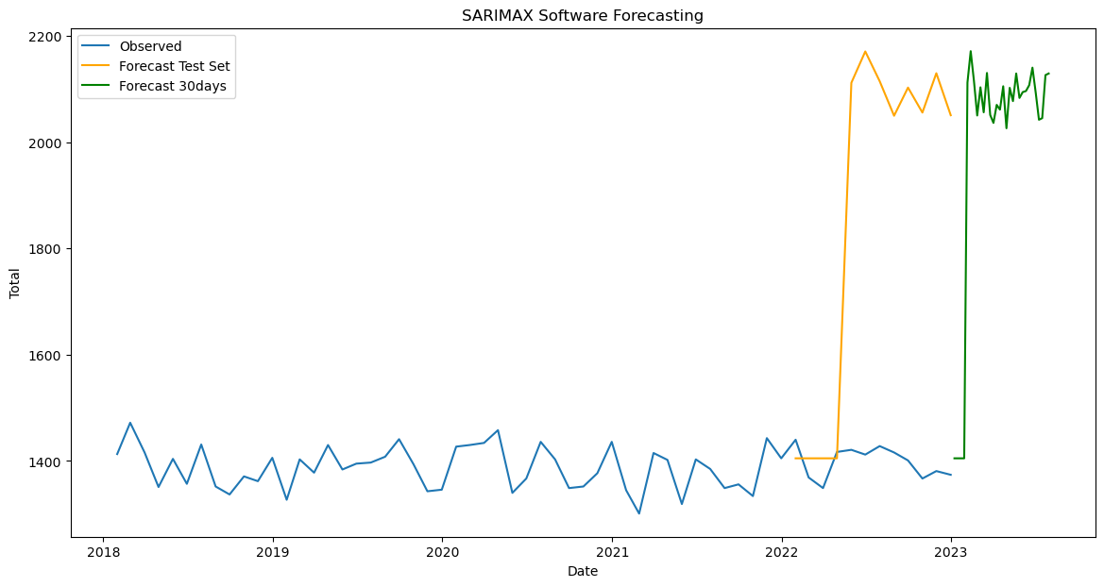

Forecast-df-30 is use to print the forecast for 30days
2023-01-08 1405.0
2023-01-15 1405.0
2023-01-22 1405.0
2023-01-29 1405.0
2023-02-05 2112.0
2023-02-12 2171.0
2023-02-19 2115.0
2023-02-26 2050.0
2023-03-05 2103.0
2023-03-12 2056.0
2023-03-19 2130.0
2023-03-26 2051.0
2023-04-02 2036.0
2023-04-09 2070.0
2023-04-16 2061.0
2023-04-23 2105.0
2023-04-30 2026.0
2023-05-07 2102.0
2023-05-14 2077.0
2023-05-21 2129.0
2023-05-28 2083.0
2023-06-04 2094.0
2023-06-11 2096.0
2023-06-18 2107.0
2023-06-25 2140.0
2023-07-02 2093.0
2023-07-09 2042.0
2023-07-16 2045.0
2023-07-23 2126.0
2023-07-30 2129.0 days.

Build a classification model to categorize incoming system issues into 'Urgent', 'High', 'Medium', or 'Low' based on factors like issue type, system component affected, and customer impact

The needed libraries was imported as found in Jupyter notebook. Dataset classification was the name assigned for the data frame. The data type of the dataset was checked by using dataset classification info(). There was no missing data in the data frame.

The customer impact was assigned to categorise the incoming system issues from Urgent, High, Medium or low based factors.

The Incoming system has a low of 350,
Medium has 329
High has 321,
This results shows that the compact impact has high value of low incoming system issues, followed by medium and lastly the compact of high has 321 value which is the lowest among the 3. The compact impact was calculated in percentage as the code can be found in Jupyter notebook.
The Incoming system has a low of 35%
Medium has 32.9%
High has 32.1%
Below is the visualisation for Customer impact.
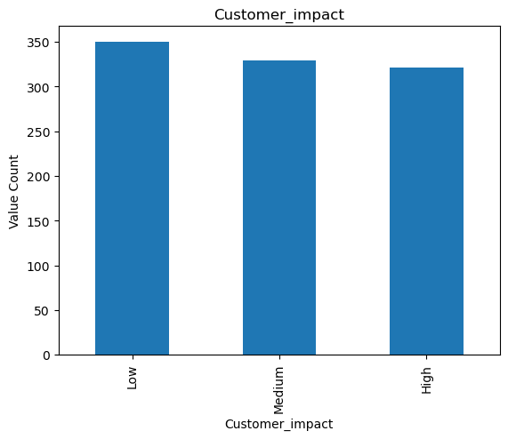

The resolve rate of the dataset was calculated, this means the performance of the resolution performance issues of the dataset. The resolve rate is 0.52.

The Visualisation below is the time spent in resolving incoming system issues. The highest time is 30hrs . Followed by 70hrs.
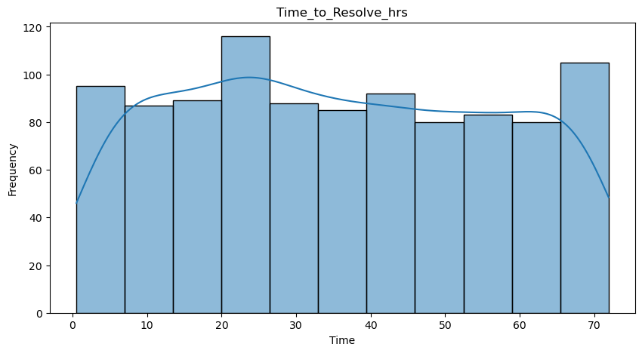

The object categories was encoded to categories. The categories was encoded to numerical columns.
The categories columns were created and encoded to numerical. The following columns was encoded to numerical. Issue Type, System ,component, Compact Impact and Resolved. The new dataset set was called dataset encoded. The dataset encoded was named for the feature selection data frame. Meaning the relevant columns was used to calculate the classification models. The X feature is the features use to make prediction. All the columns is selected, except the last column in the dataset. In the Y feature, the target variable “Resolved” will help make predictions in the data frame encoded.
The data was split into training and test set. The training set is used to notice machine learning models to learn the data from a subset. The test set is used, for impartial assessment of the model accuracy. The code can be found in Jupyter notebook. The next step is feature scaling, which is used to transform the values of features or variables in the dataset to a similar scale.

In the next step, all the Classifiers was imported with a dictionary of all the machine learning classifiers, Support Vector Classifiers(SVC), Random Forest Classifier( R.F.C), Decision Tree Classifier (D.T.C), KneighborsClssifier(KNN), Naïve Bayes Classifier(Gaussian(). This step will help to identify which algorithm perform best for a specific problem.
The next step is to analyse the different classifiers on the same dataset. This will show the best performance based on accuracy. The results are being displayed below

SVM Classifier:0.5120000000
Random Forest Classifier:0.5120000000
Decision Tree Classifier:0.4760000000
KNN Classifier:0.5600000000
Naive Bayes Classifier:0.5120000000

The result below shows that the models are finding it hard to give accurate results.

Q4 Implement an anomaly detection algorithm to identify unusual patterns in system logs that could indicate potential security threats or failures.

The features of anomaly detection was selected . The features selected are Issue Type, System Component, Customer Impact, Time-to -resolve hrs, and Resolved. Isolation forest was conducted to detect anomalies in the dataset. The model was trained using the feature selection. The next step anomalies was predicted. Anomalies labels was converted. -1 is for anomalies and 1 for normal values. The code can be found in Jupyter notebook. Anomalies was printed out to verify the values.
The variables used was Time to resolve and system component.
The visualisation below shows the Anomalies in the red dots.

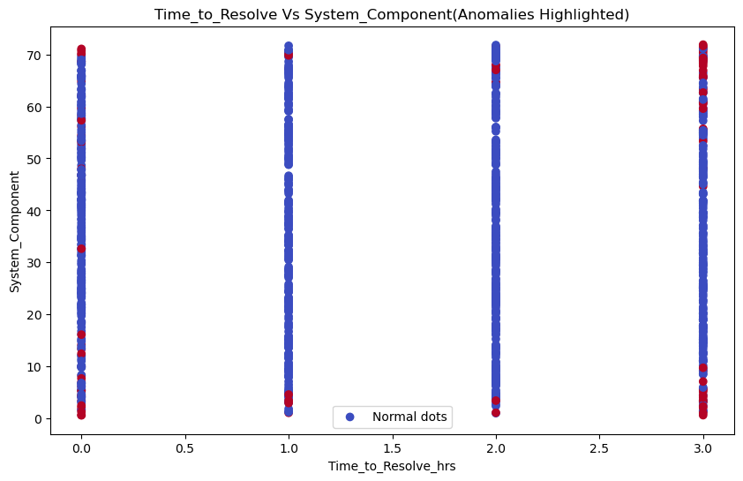

Issues type and system Component was visualised . The was no indication of anomalies in this graph.

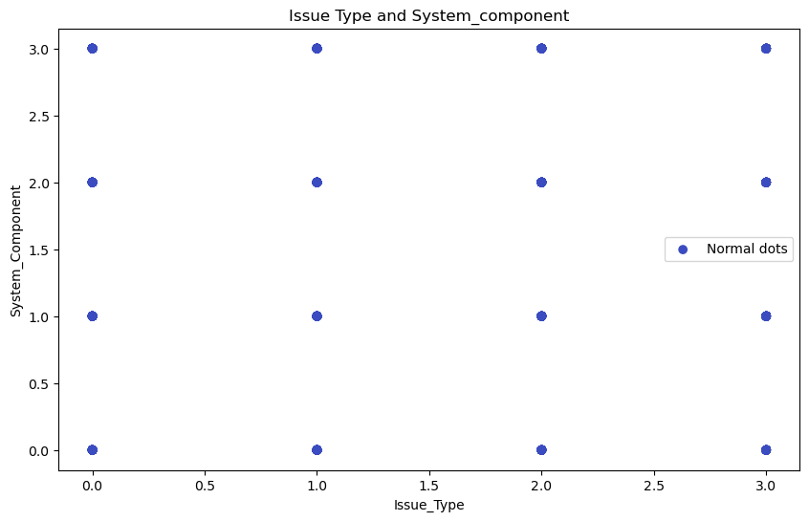
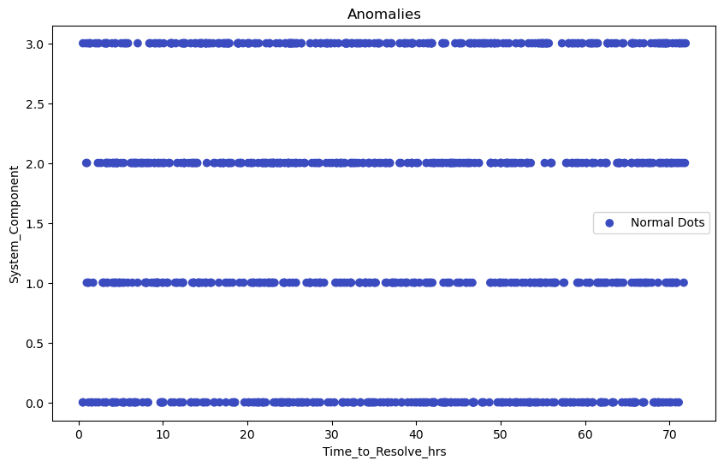
  - Sub section

The company offered the services to an online retail store. The service offers them the possibility to have at the end of the day a list with the most common items sold in the online store. Place a recommendation system and identify 3 possible recommendations for 3 random customers.

The needed libraries was imported. The dataset was loaded and called dataset retail. Data preparation was performed on the dataset. The dataset was having missing data. Below was the missing values in the dataset.
Invoice No 628
Item Code 628
Most popular item of the day 629
Quantity 628
Date 628
Unit Price 628
CustomerID 628

The dataset was cleaned by using the drop_na method in cleaning missing values. Variables in the dataset was cleaned. Customer id in the dataset retail is converted into string to facilitate the algorithm. As showed in the code in jupyter notebook. The next step is to identify the values that is greater than zero this is done by using greater than zero if there is any zero it will return, it will show as a negative number. The user item matrix will be created. This step help to understand the behaviour of the user despite the items . The name assigned is user_item_matrix. The similarity metrics was created to be able to read eligibly .

The performance of the algorithm was checked, there was an output of 17% which indicate that there is 17% error in predicting recommender system. This shows is a good score . The data was normalise to have the same unit of measurement. Single Value Decomposition was used. This important step to be able to improve the recommendation accuracy. The Single Value Decomposition results is 8.88860319449212. which shows the model is performing better. A random user is selected to be able to see the recommendations by user. An output of 94507.0 was the result of Customer ID.

A recommendation of Customer Id 94507.0 will purchase the following items. As the code can be found in Jupyter note book.

22963 1.000000
22059 0.866667
21086 0.000000

The results is displayed in a data frame. As showed in the Jupiter notebook.

- Conclusions and recommendations

The IT company can monitor their system performance to know which products is performing better to be able to advertise or improve on the other product systems.

- References

Bhandari, Aniruddha. “Feature Scaling | Standardization vs Normalization.” Analytics Vidhya, 3 Apr. 2020, www.analyticsvidhya.com/blog/2020/04/feature-scaling-machine-learning-normalization-standardization/. Accessed 30 June 2024.
Quiroz-Vázquez, Camilo. “Anomaly Detection in Machine Learning: Finding Outliers for Optimization of Business Functions.” IBM Blog, 19 Dec. 2023, www.ibm.com/blog/anomaly-detection-machine-learning/. Accessed 30 June 2024.
Pandian, Shanthababu . “A Comprehensive Guide to Time Series Analysis.” Analytics Vidhya, 23 Oct. 2021, www.analyticsvidhya.com/blog/2021/10/a-comprehensive-guide-to-time-series-analysis/. Accessed 30 June 2024.
Desai, Utsav. “Recommendation Systems Explained: Understanding the Basic to Advance.” Medium, Medium, 27 Apr. 2023, utsavdesai26.medium.com/recommendation-systems-explained-understanding-the-basic-to-advance-43a5fce77c47#:~:text=What%20is%20Recomm. Accessed 30 June 2024.

